# The Drizzle that Rained like Shooting Frogs by Matthew Ware

Steve Godfrey looked at the tattered gun in his hands and felt angry.

He walked over to the window and reflected on his sleepy surroundings. He had always hated sunny West Boggins with its wonderful, wicked waters. It was a place that encouraged his tendency to feel angry.

Then he saw something in the distance, or rather some*one*. It was the figure of Heather Russell. Heather was a noble monster with demonic legs and skinny eyelashes.

Steve gulped. He glanced at his own reflection. He was a cold-blooded, deranged, blood drinker with greasy legs and scrawny eyelashes. His friends saw him as a determined, disgusted demon. Once, he had even revived a dying, old lady.

But not even a cold-blooded person who had once revived a dying, old lady, was prepared for what Heather had in store today.

The drizzle rained like shooting frogs, making Steve barmy.

As Steve stepped outside and Heather came closer, he could see the splendid glint in her eye.

"I am here because I want revenge," Heather bellowed, in a pyscho tone. She slammed her fist against Steve's chest, with the force of 5811 owls. "I frigging hate you, Steve Godfrey."

Steve looked back, even more barmy and still fingering the tattered gun. "Heather, I want you dead," he replied.

They looked at each other with ecstatic feelings, like two creepy, cautious cats killing at a very remarkable birthday party, which had classical music playing in the background and two smelly uncles stabbing to the beat.

Steve studied Heather's demonic legs and skinny eyelashes. Eventually, he took a deep breath. "I'm sorry, but I can't give you revenge," he explained, in pitying tones.

Heather looked worried, her body raw like a brawny, broken bullet.

Steve could actually hear Heather's body shatter into 3256 pieces. Then the noble monster hurried away into the distance.

Not even a drink of blood would calm Steve's nerves tonight.

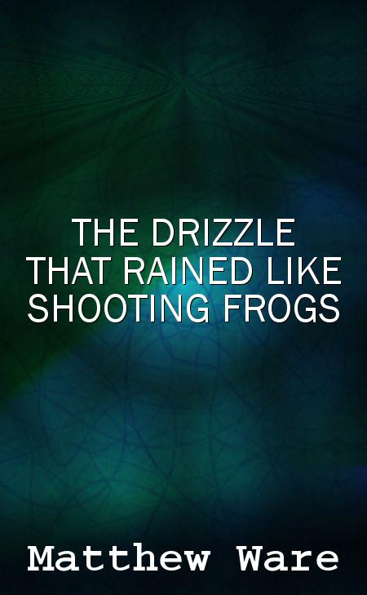

Yes, this was another generated story.